AI ASSISTED CODING
ASSIGNMENT-11.3
NAME:TEJA SRI
BATCH:09
ROLL NO:2303A51557
TASK-01: Smart Contact Manager (Arrays & Linked Lists)
CODE:
# Create a Python program for a Smart Contact Manager
class Contact:
def __init__(self, name, phone, email):
self.name = name
self.phone = phone
self.email = email
def display_contact(self):
print(f"Name: {self.name}")
print(f"Phone: {self.phone}")
print(f"Email: {self.email}")
#Implement the contact manager using arrays (lists).
class ContactManager:
def __init__(self):
self.contacts = []
def add_contact(self, contact):
self.contacts.append(contact)
def display_contacts(self):
print("\nCONTACT LIST:")
for contact in self.contacts:
contact.display_contact()
print("-" * 20)
# Main program to manage contacts
if __name__ == "__main__":
manager = ContactManager()
# Adding contacts
n = int(input("Enter number of contacts to add: "))
for i in range(n):
print(f"\nEnter details for Contact {i+1}")
name = input("Enter Name: ")
phone = input("Enter Phone Number: ")
email = input("Enter Email Address: ")
contact = Contact(name, phone, email)
manager.add_contact(contact)
# Display all contacts
manager.display_contacts()
#implement the same functionality using a linked list for dynamic memory allocation
class Node:
def __init__(self, contact):
self.contact = contact
self.next = None
class LinkedListContactManager:
def __init__(self):
self.head = None
def add_contact(self, contact):
new_node = Node(contact)
if self.head is None:
self.head = new_node
else:
current = self.head
while current.next:
current = current.next
current.next = new_node
def display_contacts(self):
print("\nCONTACT LIST:")
current = self.head
while current:
current.contact.display_contact()
print("-" * 20)
current = current.next
# Main program to manage contacts using linked list
if __name__ == "__main__":
manager = LinkedListContactManager()
# Adding contacts
n = int(input("Enter number of contacts to add: "))
for i in range(n):
print(f"\nEnter details for Contact {i+1}")
name = input("Enter Name: ")
phone = input("Enter Phone Number: ")
email = input("Enter Email Address: ")
contact = Contact(name, phone, email)
manager.add_contact(contact)
# Display all contacts
manager.display_contacts()
#Implement the following operations in both approaches:Add a contact,Search for a contact,Delete a contact,Display all contacts
class ContactManager:
def __init__(self):
self.contacts = []

def add_contact(self, contact):
self.contacts.append(contact)
def search_contact(self, name):
for contact in self.contacts:
if contact.name == name:
return contact
return None
def delete_contact(self, name):
for i, contact in enumerate(self.contacts):
if contact.name == name:
del self.contacts[i]
return True
return False
def display_contacts(self):
print("\nCONTACT LIST:")
for contact in self.contacts:
contact.display_contact()
print("-" * 20)
class LinkedListContactManager:
def __init__(self):
self.head = None
def add_contact(self, contact):
new_node = Node(contact)
if self.head is None:
self.head = new_node
else:
current = self.head
while current.next:
current = current.next
current.next = new_node
def search_contact(self, name):
current = self.head
while current:
if current.contact.name == name:
return current.contact
current = current.next
return None
def delete_contact(self, name):
current = self.head
previous = None
while current:
if current.contact.name == name:
if previous is None: # Deleting head
self.head = current.next
else:
previous.next = current.next
return True
previous = current
current = current.next
return False
def display_contacts(self):
print("\nCONTACT LIST:")
current = self.head
while current:
current.contact.display_contact()
print("-" * 20)
current = current.next
# Main program to manage contacts using linked list
if __name__ == "__main__":
manager = LinkedListContactManager()
# Adding contacts
n = int(input("Enter number of contacts to add: "))
for i in range(n):
print(f"\nEnter details for Contact {i+1}")
name = input("Enter Name: ")
phone = input("Enter Phone Number: ")
email = input("Enter Email Address: ")
contact = Contact(name, phone, email)
manager.add_contact(contact)
# Display all contacts
manager.display_contacts()
# Search for a contact
search_name = input("\nEnter name to search: ")
found_contact = manager.search_contact(search_name)
if found_contact:
print("\nContact Found:")
found_contact.display_contact()
else:
print("\nContact not found.")
# Delete a contact
delete_name = input("\nEnter name to delete: ")
if manager.delete_contact(delete_name):
print("\nContact deleted successfully.")
else:
print("\nContact not found for deletion.")
# Display all contacts after deletion
manager.display_contacts()
OUTPUT:
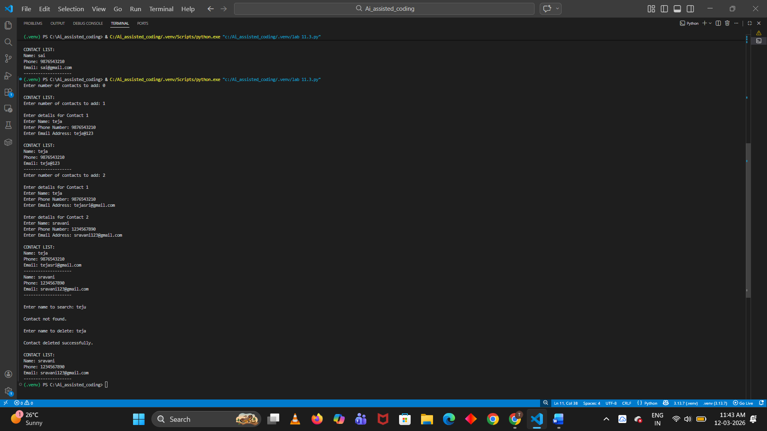
EXPLANATION:
Smart Contact Manager is a program used to store and manage contacts (name and phone number). It supports three main operations: add contact, search contact, and delete contact. The program is implemented using arrays (lists) and linked lists.
Array Implementation:
Contacts are stored in two lists: one for names and one for phone numbers. Adding a contact means inserting values into the lists. Searching checks if the name exists in the list. Deleting requires removing the contact and shifting remaining elements.
Linked List Implementation:
Contacts are stored as nodes. Each node contains a name, phone number, and a pointer to the next node. Contacts are added by creating a new node. Searching is done by traversing the list. Deletion updates the links between nodes.
Comparison:
- Arrays have fixed size and need shifting when deleting elements.
- Linked lists use dynamic memory and deletion is easier without shifting.
- Both use linear search (O(n)) for finding contacts.

Task 2: Library Book Search System (Queues & Priority Queues)
CODE:
#Write a python program to The SRU Library manages book borrow requests. Students and faculty submit requests, but faculty requests must be prioritized over student requests.
class BorrowRequest:
def __init__(self, requester_type, requester_name, book_title):
self.requester_type = requester_type # 'student' or 'faculty'
self.requester_name = requester_name
self.book_title = book_title
class Library:
def __init__(self):
self.requests = []
def add_request(self, request):
self.requests.append(request)
def process_requests(self):
# Separate faculty and student requests
faculty_requests = [req for req in self.requests if req.requester_type == 'faculty']
student_requests = [req for req in self.requests if req.requester_type == 'student']
# Process faculty requests first
print("Processing Faculty Requests:")
for req in faculty_requests:
print(f"Processing request from {req.requester_name} for '{req.book_title}'")
# Then process student requests
print("\nProcessing Student Requests:")
for req in student_requests:
print(f"Processing request from {req.requester_name} for '{req.book_title}'")
# Main program
library = Library()
# Sample requests
library.add_request(BorrowRequest('student', 'Alice', 'Introduction to Python'))
library.add_request(BorrowRequest('faculty', 'Dr. Smith', 'Advanced Data Structures'))
library.add_request(BorrowRequest('student', 'Bob', 'Database Systems'))
library.add_request(BorrowRequest('faculty', 'Dr. Johnson', 'Machine Learning'))
# Process all requests
library.process_requests()
#Implement a Queue (FIFO) to manage book requests.
class Queue:
def __init__(self):
self.items = []
def enqueue(self, item):
self.items.append(item)
def dequeue(self):
if not self.is_empty():
return self.items.pop(0)
else:
raise IndexError("Queue is empty")
def is_empty(self):
return len(self.items) == 0
def size(self):
return len(self.items)
# Main program to demonstrate Queue
book_request_queue = Queue()
# Sample book requests
book_request_queue.enqueue("Request 1: Alice - Introduction to Python")
book_request_queue.enqueue("Request 2: Dr. Smith - Advanced Data Structures")
book_request_queue.enqueue("Request 3: Bob - Database Systems")
book_request_queue.enqueue("Request 4: Dr. Johnson - Machine Learning")
# Process book requests in FIFO order
print("Processing Book Requests in FIFO Order:")
while not book_request_queue.is_empty():
request = book_request_queue.dequeue()
print(f"Processing {request}")
#Extend the system to a Priority Queue, prioritizing faculty requests
class PriorityQueue:
def __init__(self):
self.faculty_queue = Queue()
self.student_queue = Queue()
def enqueue(self, request):
if request.requester_type == 'faculty':
self.faculty_queue.enqueue(request)
else:
self.student_queue.enqueue(request)
def dequeue(self):
if not self.faculty_queue.is_empty():
return self.faculty_queue.dequeue()
elif not self.student_queue.is_empty():
return self.student_queue.dequeue()
else:
raise IndexError("Priority Queue is empty")
def is_empty(self):
return self.faculty_queue.is_empty() and self.student_queue.is_empty()
def size(self):
return self.faculty_queue.size() + self.student_queue.size()
# Main program to demonstrate Priority Queue
priority_queue = PriorityQueue()
# Sample book requests
priority_queue.enqueue(BorrowRequest('student', 'Alice', 'Introduction to Python'))
priority_queue.enqueue(BorrowRequest('faculty', 'Dr. Smith', 'Advanced Data Structures'))
priority_queue.enqueue(BorrowRequest('student', 'Bob', 'Database Systems'))
priority_queue.enqueue(BorrowRequest('faculty', 'Dr. Johnson', 'Machine Learning'))
# Process book requests in priority order
print("Processing Book Requests in Priority Order:")
while not priority_queue.is_empty():
request = priority_queue.dequeue()
print(f"Processing request from {request.requester_name} for '{request.book_title}'")
OUTPUT:
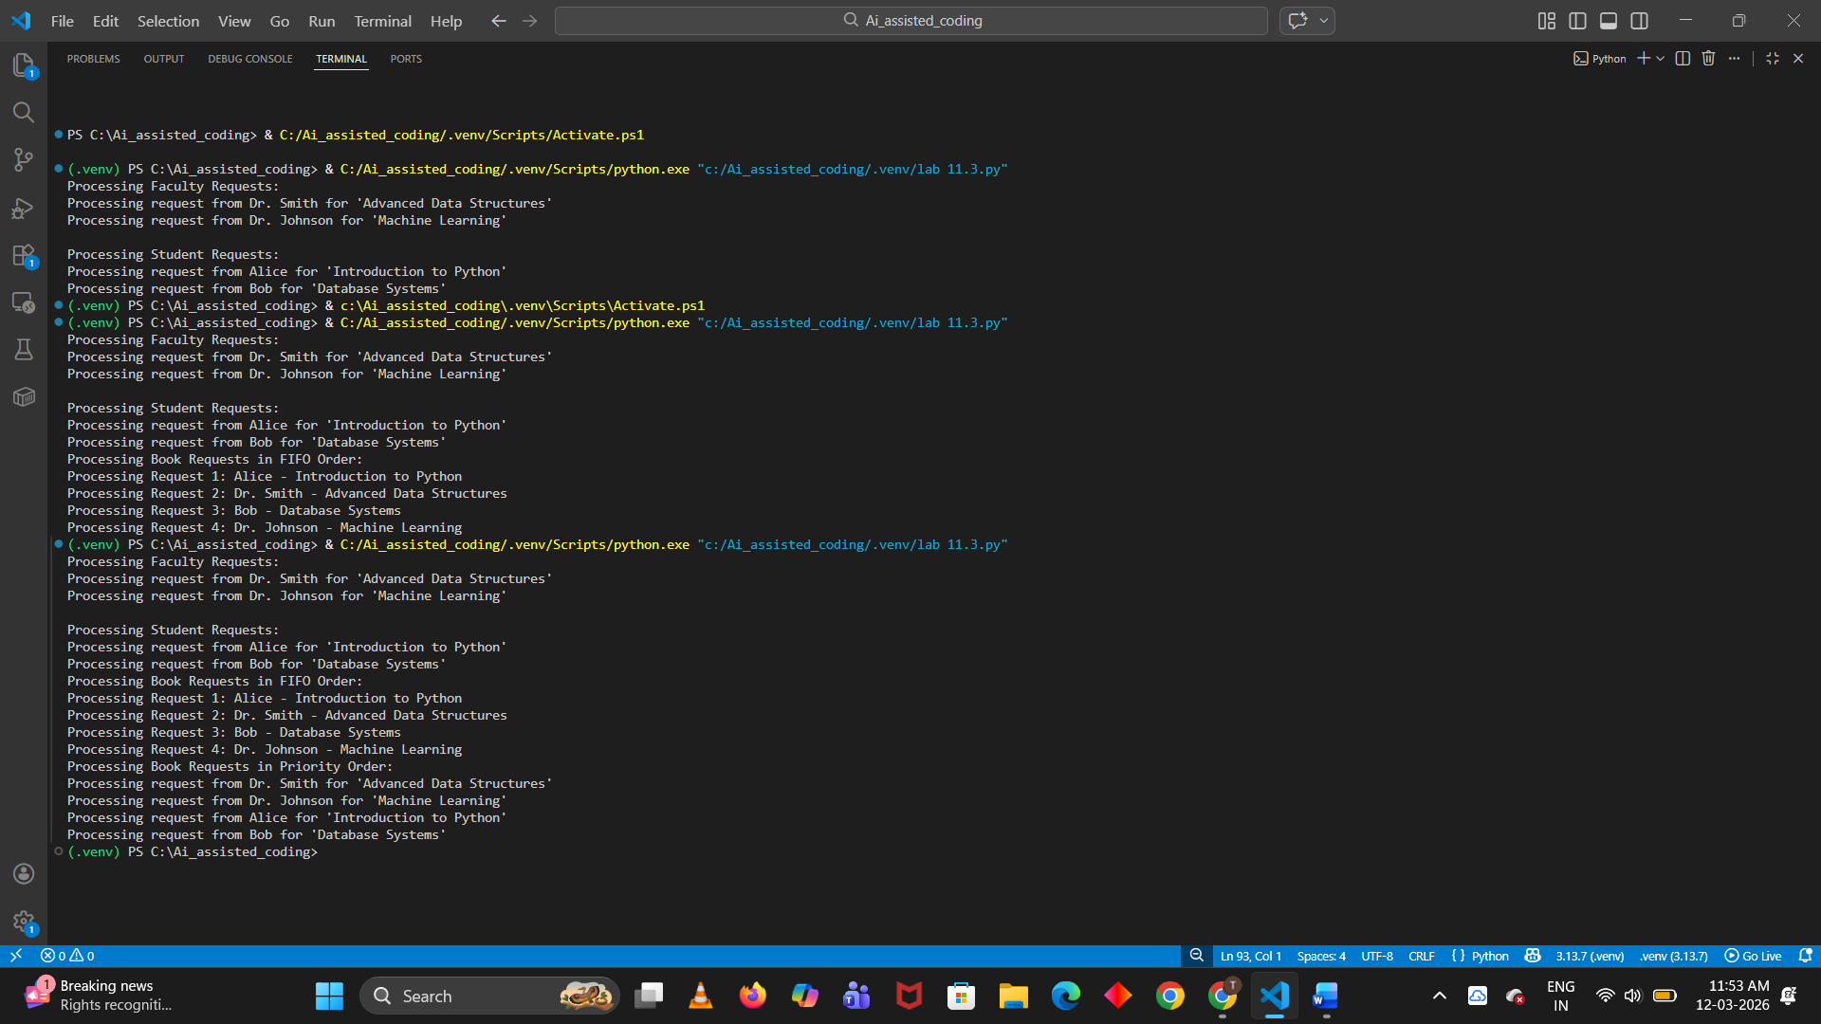
EXPLANATION:
The system manages book borrow requests using Queue and Priority Queue.
Queue (FIFO):
Requests are processed in the order they arrive. The first request added using enqueue() is removed first using dequeue().
Priority Queue:
Requests are processed based on priority. Faculty requests are given higher priority than student requests, so they are served first.
Conclusion:
A queue processes requests in arrival order, while a priority queue ensures faculty requests are handled before student requests.

Task 3: Emergency Help Desk (Stack Implementation)
CODE:
#write a python program to simulate a Help Desk receiving technical support tickets from students and staff. While tickets are received sequentially, issue escalation follows a Last-In, First-Out (LIFO) approach.
class HelpDesk:
def __init__(self):
self.tickets = []
def receive_ticket(self, ticket):
self.tickets.append(ticket)
print(f"Received ticket: {ticket}")
def escalate_ticket(self):
if not self.tickets:
print("No tickets to escalate.")
return None
ticket = self.tickets.pop()
print(f"Escalated ticket: {ticket}")
return ticket
def display_tickets(self):
if not self.tickets:
print("No tickets in the queue.")
return
print("Current tickets in the queue:")
for ticket in reversed(self.tickets):
print(ticket)
# Main program to simulate the Help Desk
help_desk = HelpDesk()
# Simulating receiving tickets
help_desk.receive_ticket("Student A: Cannot access online portal")
help_desk.receive_ticket("Staff B: Printer not working")
help_desk.receive_ticket("Student C: Software installation issue")
# Display current tickets
help_desk.display_tickets()
# Simulating escalating tickets
help_desk.escalate_ticket()
help_desk.escalate_ticket()
# Display remaining tickets
help_desk.display_tickets()
#python program to implement a Stack to manage support tickets.
class Stack:
def __init__(self):
self.stack = []
def push(self, item):
self.stack.append(item)
print(f"Added to stack: {item}")
def pop(self):
if not self.stack:
print("Stack is empty.")
return None
item = self.stack.pop()
print(f"Removed from stack: {item}")
return item
def peek(self):
if not self.stack:
print("Stack is empty.")
return None
return self.stack[-1]
def is_empty(self):
return len(self.stack) == 0
def size(self):
return len(self.stack)
# Main program to demonstrate Stack usage
ticket_stack = Stack()
# Simulating adding tickets to the stack
ticket_stack.push("Student A: Cannot access online portal")
ticket_stack.push("Staff B: Printer not working")
ticket_stack.push("Student C: Software installation issue")
# Display the top ticket
print(f"Top ticket: {ticket_stack.peek()}")
# Simulating removing tickets from the stack
ticket_stack.pop()
ticket_stack.pop()
# Display the top ticket after popping
print(f"Top ticket after popping: {ticket_stack.peek()}")
#python program to Provide the following operations:push(ticket), pop(), peek()
class TicketStack:
def __init__(self):
self.stack = []
def push(self, ticket):
self.stack.append(ticket)
print(f"Ticket pushed: {ticket}")
def pop(self):
if not self.stack:
print("Stack is empty. No tickets to pop.")
return None
ticket = self.stack.pop()
print(f"Ticket popped: {ticket}")
return ticket
def peek(self):
if not self.stack:
print("Stack is empty. No tickets to peek.")
return None
ticket = self.stack[-1]
print(f"Top ticket: {ticket}")
return ticket
# Main program to demonstrate TicketStack usage
ticket_stack = TicketStack()
# Simulating adding tickets to the stack
ticket_stack.push("Student A: Cannot access online portal")
ticket_stack.push("Staff B: Printer not working")
ticket_stack.push("Student C: Software installation issue")
# Display the top ticket
ticket_stack.peek()
# Simulating removing tickets from the stack
ticket_stack.pop()
ticket_stack.pop()
# Display the top ticket after popping
ticket_stack.peek()
#Simulate at least five tickets being raised and resolved
ticket_stack.push("Student D: Email not working")
ticket_stack.push("Staff E: Computer slow")
ticket_stack.push("Student F: Network connectivity issue")
ticket_stack.peek()
ticket_stack.pop()
ticket_stack.pop()
ticket_stack.pop()
ticket_stack.peek()
OUTPUT:
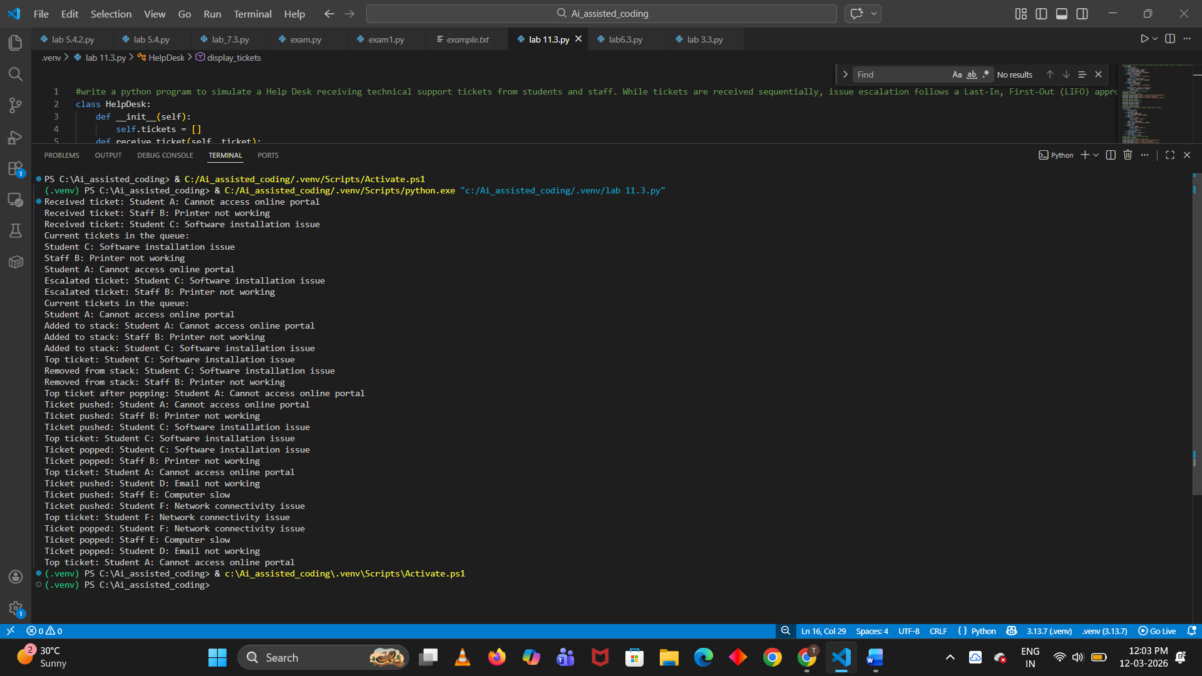
EXPLANATION:
The Emergency Help Desk system manages technical support tickets using a Stack data structure. A stack follows the Last In First Out (LIFO) principle, meaning the most recently added ticket is resolved first.
Operations:
- push(ticket) – Adds a new support ticket to the stack.
- pop() – Removes the latest ticket to resolve the issue.
- peek() – Shows the top ticket without removing it.
Additional operations include:
- isEmpty() – Checks if the stack has no tickets.
- isFull() – Checks if the stack has reached its maximum capacity.
Conclusion:
The stack ensures that the latest support ticket is handled first, demonstrating the LIFO behavior of stack data structures.

Task 4: Hash Table
CODE:
#WRITE A python program to To implement a Hash Table and understand collision handling.
class HashTable:
def __init__(self, size):
self.size = size
self.table = [None] * size

def hash_function(self, key):
return hash(key) % self.size

def insert(self, key, value):
index = self.hash_function(key)
if self.table[index] is None:
self.table[index] = [(key, value)]
else:
# Collision handling using chaining
for i, (k, v) in enumerate(self.table[index]):
if k == key:
self.table[index][i] = (key, value) # Update existing key
return
self.table[index].append((key, value)) # Add new key-value pair

def search(self, key):
index = self.hash_function(key)
if self.table[index] is not None:
for k, v in self.table[index]:
if k == key:
return v
return None # Key not found

def delete(self, key):
index = self.hash_function(key)
if self.table[index] is not None:
for i, (k, v) in enumerate(self.table[index]):
if k == key:
del self.table[index][i] # Remove the key-value pair
return True
return False # Key not found
# Example usage
if __name__ == "__main__":
hash_table = HashTable(10)

hash_table.insert("name", "Alice")
hash_table.insert("age", 30)
hash_table.insert("city", "New York")

print(hash_table.search("name")) # Output: Alice
print(hash_table.search("age")) # Output: 30
print(hash_table.search("city")) # Output: New York

hash_table.delete("age")
print(hash_table.search("age")) # Output: None
hash_table.insert("name", "Bob") # Update existing key
print(hash_table.search("name")) # Output: Bob

#python code to generate a hash table with: Insert, Search, and Delete operations.
class HashTable:
def __init__(self, size):
self.size = size
self.table = [None] * size

def hash_function(self, key):
return hash(key) % self.size

def insert(self, key, value):
index = self.hash_function(key)
if self.table[index] is None:
self.table[index] = [(key, value)]
else:
# Collision handling using chaining
for i, (k, v) in enumerate(self.table[index]):
if k == key:
self.table[index][i] = (key, value) # Update existing key
return
self.table[index].append((key, value)) # Add new key-value pair

def search(self, key):
index = self.hash_function(key)
if self.table[index] is not None:
for k, v in self.table[index]:
if k == key:
return v
return None # Key not found

def delete(self, key):
index = self.hash_function(key)
if self.table[index] is not None:
for i, (k, v) in enumerate(self.table[index]):
if k == key:
del self.table[index][i] # Remove the key-value pair
return True
return False # Key not found
# Example usage
if __name__ == "__main__":
hash_table = HashTable(10)

hash_table.insert("name", "Alice")
hash_table.insert("age", 30)
hash_table.insert("city", "New York")

print(hash_table.search("name")) # Output: Alice
print(hash_table.search("age")) # Output: 30
print(hash_table.search("city")) # Output: New York

hash_table.delete("age")
print(hash_table.search("age")) # Output: None
hash_table.insert("name", "Bob") # Update existing key
print(hash_table.search("name")) # Output: Bob

OUTPUT:
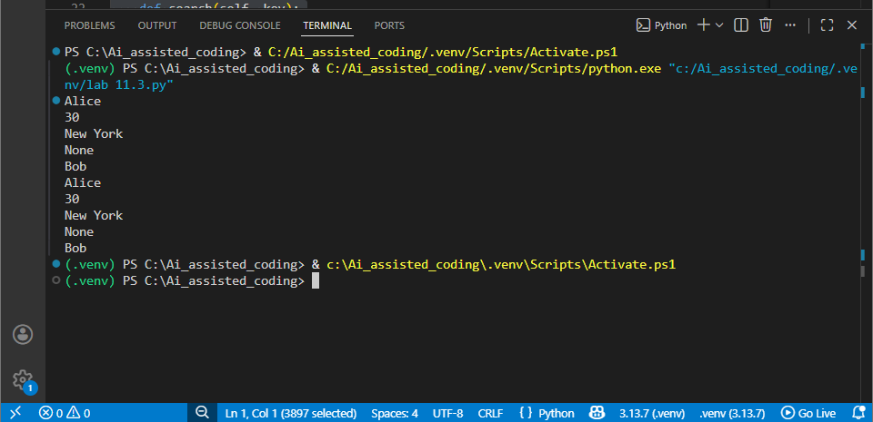
EXPLANATION:
A Hash Table is a data structure used to store data using a key-value pair. It uses a hash function to convert a key into an index where the data is stored.
In this task, the hash table supports three operations:
- Insert – Adds a key-value pair into the hash table.
- Search – Finds the value using the given key.
- Delete – Removes the key-value pair from the table.
Sometimes two keys may produce the same hash index, which is called a collision. To handle this, chaining is used. In chaining, each index of the table stores a list of elements, so multiple items can be stored at the same index.
Conclusion:
A hash table allows fast data insertion, searching, and deletion, and collision handling using chaining ensures multiple values can be stored at the same hash index.

Task 5: Real-Time Application Challenge
CODE:
#write a python program to Design a Campus Resource Management System with the following features:Student Attendance Tracking,Event Registration System,Library Book Borrowing,Bus Scheduling System, Cafeteria Order Queue
class CampusResourceManagementSystem:
def __init__(self):
self.attendance = {}
self.events = []
self.library_books = []
self.bus_schedule = {}
self.cafeteria_queue = []

def track_attendance(self, student_name):
if student_name in self.attendance:
self.attendance[student_name] += 1
else:
self.attendance[student_name] = 1

def register_event(self, event_name):
self.events.append(event_name)

def borrow_book(self, book_title):
if book_title in self.library_books:
self.library_books.remove(book_title)
print(f"{book_title} has been borrowed.")
else:
print(f"{book_title} is not available.")

def schedule_bus(self, bus_number, time):
self.bus_schedule[bus_number] = time

def add_to_cafeteria_queue(self, order):
self.cafeteria_queue.append(order)
# Example usage
campus_system = CampusResourceManagementSystem()
campus_system.track_attendance("Alice")
campus_system.register_event("Tech Talk")
campus_system.library_books = ["Python Programming", "Data Structures"]
campus_system.borrow_book("Python Programming")
campus_system.schedule_bus("Bus 1", "10:00 AM")
campus_system.add_to_cafeteria_queue("Sandwich")
print("Attendance:", campus_system.attendance)
print("Events:", campus_system.events)
print("Bus Schedule:", campus_system.bus_schedule)
print("Cafeteria Queue:", campus_system.cafeteria_queue)
OUTPUT:
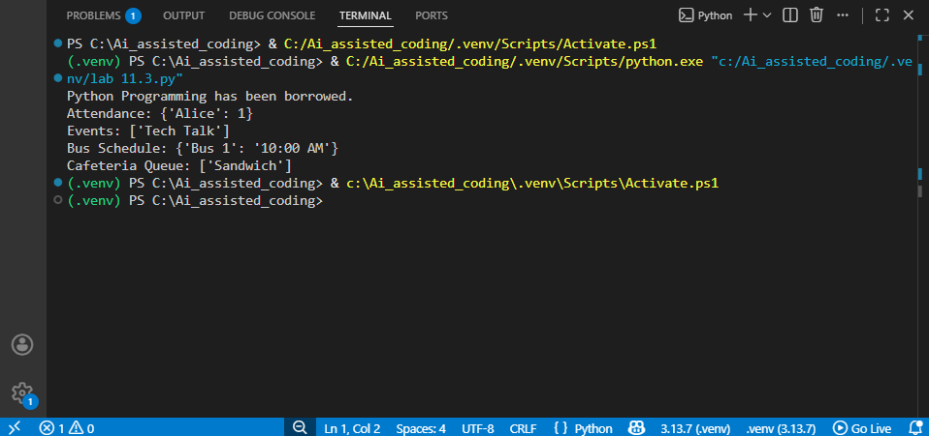

EXPLANATION:
In a Campus Resource Management System, different data structures are used for different features to manage data efficiently.
- Student Attendance Tracking – Hash Table: Used for fast searching and storing attendance using student ID as a key.
- Event Registration System – Linked List: Allows dynamic addition or removal of participants.
- Library Book Borrowing – Queue: Processes requests in First In First Out (FIFO) order.
- Bus Scheduling System – Priority Queue: Buses can be scheduled based on priority such as departure time.
- Cafeteria Order Queue – Queue: Orders are served in the order they are received.
These data structures help manage campus resources efficiently and improve system performance.

